**Lab 8 *– Activity Login***

**Layout Code**

**Activity_main.xml**

<?xml version="1.0" encoding="utf-8"?>  
<android.support.constraint.ConstraintLayout xmlns:android="http://schemas.android.com/apk/res/android"  
 xmlns:app="http://schemas.android.com/apk/res-auto"  
 xmlns:tools="http://schemas.android.com/tools"  
 android:layout_width="match_parent"  
 android:layout_height="match_parent"  
 tools:context=".MainActivity">  
  
 <ImageView  
 android:id="@+id/imageView"  
 android:layout_width="163dp"  
 android:layout_height="149dp"  
 android:contentDescription="@string/user"  
 android:visibility="visible"  
 app:layout_constraintBottom_toBottomOf="parent"  
 app:layout_constraintEnd_toEndOf="parent"  
 app:layout_constraintStart_toStartOf="parent"  
 app:layout_constraintTop_toTopOf="parent"  
 app:layout_constraintVertical_bias="0.06"  
 tools:srcCompat="@drawable/ic_baseline_account_box_24" />  
  
 <TextView  
 android:id="@+id/titleLogin"  
 android:layout_width="wrap_content"  
 android:layout_height="wrap_content"  
 android:text="@string/login_here"  
 android:textColor="#3C3A3A"  
 android:textSize="30sp"  
 android:textStyle="bold"  
 app:layout_constraintBottom_toBottomOf="parent"  
 app:layout_constraintEnd_toEndOf="parent"  
 app:layout_constraintHorizontal_bias="0.497"  
 app:layout_constraintLeft_toLeftOf="parent"  
 app:layout_constraintRight_toRightOf="parent"  
 app:layout_constraintStart_toStartOf="parent"  
 app:layout_constraintTop_toTopOf="parent"  
 app:layout_constraintVertical_bias="0.293" />  
  
 <TextView  
 android:id="@+id/titleUsername"  
 android:layout_width="wrap_content"  
 android:layout_height="wrap_content"  
 android:text="@string/username"  
 android:textColor="#3C3A3A"  
 android:textSize="28sp"  
 android:textStyle="bold"  
 app:layout_constraintBottom_toBottomOf="parent"  
 app:layout_constraintEnd_toEndOf="parent"  
 app:layout_constraintHorizontal_bias="0.2"  
 app:layout_constraintLeft_toLeftOf="parent"  
 app:layout_constraintRight_toRightOf="parent"  
 app:layout_constraintStart_toStartOf="parent"  
 app:layout_constraintTop_toTopOf="parent"  
 app:layout_constraintVertical_bias="0.395" />  
  
 <EditText  
 android:id="@+id/editTextTextUsername"  
 android:layout_width="wrap_content"  
 android:layout_height="47dp"  
 android:layout_marginStart="52dp"  
 android:layout_marginLeft="52dp"  
 android:layout_marginEnd="52dp"  
 android:layout_marginRight="52dp"  
 android:ems="10"  
 android:hint="@string/enter_username"  
 android:importantForAutofill="no"  
 android:inputType="textPersonName"  
 android:textSize="24sp"  
 app:layout_constraintBottom_toBottomOf="parent"  
 app:layout_constraintEnd_toEndOf="parent"  
 app:layout_constraintHorizontal_bias="0.111"  
 app:layout_constraintStart_toStartOf="parent"  
 app:layout_constraintTop_toTopOf="parent"  
 app:layout_constraintVertical_bias="0.482" />  
  
 <TextView  
 android:id="@+id/titlePassword"  
 android:layout_width="wrap_content"  
 android:layout_height="wrap_content"  
 android:text="@string/password"  
 android:textColor="#3C3A3A"  
 android:textSize="28sp"  
 android:textStyle="bold"  
 app:layout_constraintBottom_toBottomOf="parent"  
 app:layout_constraintEnd_toEndOf="parent"  
 app:layout_constraintHorizontal_bias="0.196"  
 app:layout_constraintLeft_toLeftOf="parent"  
 app:layout_constraintRight_toRightOf="parent"  
 app:layout_constraintStart_toStartOf="parent"  
 app:layout_constraintTop_toTopOf="parent"  
 app:layout_constraintVertical_bias="0.572" />  
  
 <EditText  
 android:id="@+id/editTextTextUserPassword"  
 android:layout_width="wrap_content"  
 android:layout_height="47dp"  
 android:layout_marginStart="52dp"  
 android:layout_marginLeft="52dp"  
 android:layout_marginEnd="52dp"  
 android:layout_marginRight="52dp"  
 android:ems="10"  
 android:hint="@string/enter_password"  
 android:importantForAutofill="no"  
 android:inputType="textPersonName|textPassword"  
 android:textSize="24sp"  
 app:layout_constraintBottom_toBottomOf="parent"  
 app:layout_constraintEnd_toEndOf="parent"  
 app:layout_constraintHorizontal_bias="0.111"  
 app:layout_constraintStart_toStartOf="parent"  
 app:layout_constraintTop_toTopOf="parent"  
 app:layout_constraintVertical_bias="0.663" />  
  
 <Button  
 android:id="@+id/Loginbutton"  
 android:layout_width="114dp"  
 android:layout_height="62dp"  
 android:text="@string/login"  
 android:textSize="24sp"  
 android:textStyle="bold"  
 app:layout_constraintBottom_toBottomOf="parent"  
 app:layout_constraintEnd_toEndOf="parent"  
 app:layout_constraintHorizontal_bias="0.498"  
 app:layout_constraintStart_toStartOf="parent"  
 app:layout_constraintTop_toTopOf="parent"  
 app:layout_constraintVertical_bias="0.79" />  
  
</android.support.constraint.ConstraintLayout>

**Activity_dash_board.xml**

<?xml version="1.0" encoding="utf-8"?>  
<android.support.constraint.ConstraintLayout xmlns:android="http://schemas.android.com/apk/res/android"  
 xmlns:app="http://schemas.android.com/apk/res-auto"  
 xmlns:tools="http://schemas.android.com/tools"  
 android:layout_width="match_parent"  
 android:layout_height="match_parent"  
 tools:context=".DashBoard">  
  
 <TextView  
 android:id="@+id/textView"  
 android:layout_width="wrap_content"  
 android:layout_height="wrap_content"  
 android:text="@string/services"  
 android:textColor="#0E0E0E"  
 android:textSize="30sp"  
 app:layout_constraintBottom_toBottomOf="parent"  
 app:layout_constraintEnd_toEndOf="parent"  
 app:layout_constraintStart_toStartOf="parent"  
 app:layout_constraintTop_toTopOf="parent"  
 app:layout_constraintVertical_bias="0.02" />  
  
 <ImageButton  
 android:id="@+id/imageButtonWeb"  
 android:layout_width="280dp"  
 android:layout_height="150dp"  
 android:contentDescription="@string/newtreatweblink"  
 app:layout_constraintBottom_toBottomOf="parent"  
 app:layout_constraintEnd_toEndOf="parent"  
 app:layout_constraintHorizontal_bias="0.495"  
 app:layout_constraintStart_toStartOf="parent"  
 app:layout_constraintTop_toTopOf="parent"  
 app:layout_constraintVertical_bias="0.103"  
 app:srcCompat="@drawable/comp"  
 tools:ignore="VectorDrawableCompat" />  
  
 <ImageButton  
 android:id="@+id/makeCall"  
 android:layout_width="280dp"  
 android:layout_height="150dp"  
 android:contentDescription="@string/todo"  
 app:layout_constraintBottom_toBottomOf="parent"  
 app:layout_constraintEnd_toEndOf="parent"  
 app:layout_constraintHorizontal_bias="0.495"  
 app:layout_constraintStart_toStartOf="parent"  
 app:layout_constraintTop_toTopOf="parent"  
 app:layout_constraintVertical_bias="0.385"  
 app:srcCompat="@drawable/phone"  
 tools:ignore="VectorDrawableCompat" />  
  
 <ImageButton  
 android:id="@+id/sendMail"  
 android:layout_width="280dp"  
 android:layout_height="150dp"  
 android:contentDescription="@string/todo"  
 app:layout_constraintBottom_toBottomOf="parent"  
 app:layout_constraintEnd_toEndOf="parent"  
 app:layout_constraintHorizontal_bias="0.495"  
 app:layout_constraintStart_toStartOf="parent"  
 app:layout_constraintTop_toTopOf="parent"  
 app:layout_constraintVertical_bias="0.657"  
 app:srcCompat="@drawable/mail"  
 tools:ignore="VectorDrawableCompat" />  
  
 <ImageButton  
 android:id="@+id/openMap"  
 android:layout_width="280dp"  
 android:layout_height="150dp"  
 android:contentDescription="@string/todo"  
 app:layout_constraintBottom_toBottomOf="parent"  
 app:layout_constraintEnd_toEndOf="parent"  
 app:layout_constraintHorizontal_bias="0.495"  
 app:layout_constraintStart_toStartOf="parent"  
 app:layout_constraintTop_toTopOf="parent"  
 app:layout_constraintVertical_bias="0.92"  
 app:srcCompat="@drawable/map"  
 tools:ignore="VectorDrawableCompat" />  
  
 <View  
 android:id="@+id/divider"  
 android:layout_width="match_parent"  
 android:layout_height="1dp"  
 android:background="?android:attr/listDivider"  
 app:layout_constraintBottom_toBottomOf="parent"  
 app:layout_constraintEnd_toEndOf="parent"  
 app:layout_constraintHorizontal_bias="0.0"  
 app:layout_constraintStart_toStartOf="parent"  
 app:layout_constraintTop_toTopOf="parent"  
 app:layout_constraintVertical_bias="0.282" />  
  
 <View  
 android:id="@+id/divider2"  
 android:layout_width="match_parent"  
 android:layout_height="1dp"  
 android:background="?android:attr/listDivider"  
 app:layout_constraintBottom_toBottomOf="parent"  
 app:layout_constraintEnd_toEndOf="parent"  
 app:layout_constraintHorizontal_bias="0.0"  
 app:layout_constraintStart_toStartOf="parent"  
 app:layout_constraintTop_toTopOf="parent"  
 app:layout_constraintVertical_bias="0.738" />  
  
 <View  
 android:id="@+id/divider3"  
 android:layout_width="match_parent"  
 android:layout_height="1dp"  
 android:background="?android:attr/listDivider"  
 app:layout_constraintBottom_toBottomOf="parent"  
 app:layout_constraintEnd_toEndOf="parent"  
 app:layout_constraintHorizontal_bias="1.0"  
 app:layout_constraintStart_toStartOf="parent"  
 app:layout_constraintTop_toTopOf="parent"  
 app:layout_constraintVertical_bias="0.516" />  
  
</android.support.constraint.ConstraintLayout>

**JAVA Code**

**MainActivity.java**

package com.example.activitylogin;  
  
import android.content.Intent;  
import android.support.v7.app.AppCompatActivity;  
import android.os.Bundle;  
import android.view.View;  
import android.widget.Button;  
import android.widget.EditText;  
import android.widget.Toast;  
  
  
public class MainActivity extends AppCompatActivity {  
 private EditText docUsername, docPassword;  
 private final String username = "Avi";  
 private final String password = "1234";  
 @Override  
 protected void onCreate(Bundle savedInstanceState) {  
 super.onCreate(savedInstanceState);  
 setContentView(R.layout.*activity_main*);  
  
 docUsername = findViewById(R.id.*editTextTextUsername*);  
 docPassword = findViewById(R.id.*editTextTextUserPassword*);  
  
 Button btnLogin = findViewById(R.id.*Loginbutton*);  
  
 btnLogin.setOnClickListener(new View.OnClickListener() {  
 @Override  
 public void onClick(View v) {  
  
 String inputUsername = docUsername.getText().toString();  
 String inputPassword = docPassword.getText().toString();  
  
 if(inputUsername.equals(username) && inputPassword.equals(password)){  
 Toast.*makeText*(MainActivity.this, "Login Successful", Toast.*LENGTH_SHORT*).show();  
 Intent myIntent = new Intent(MainActivity.this, DashBoard.class);  
 MainActivity.this.startActivity(myIntent);  
 } else{  
 Toast.*makeText*(MainActivity.this, "Login Unsuccessful!!!!", Toast.*LENGTH_SHORT*).show();  
 }  
 }  
 }); } }

**DashBoard.java**

package com.example.activitylogin;  
  
import android.content.Intent;  
import android.net.Uri;  
import android.support.v7.app.AppCompatActivity;  
import android.os.Bundle;  
import android.util.Log;  
import android.view.View;  
import android.widget.ImageButton;  
import android.widget.Toast;  
  
public class DashBoard extends AppCompatActivity {  
  
 @Override  
 protected void onCreate(Bundle savedInstanceState) {  
 super.onCreate(savedInstanceState);  
 setContentView(R.layout.*activity_dash_board*);  
  
 ImageButton btnWebsite = findViewById(R.id.*imageButtonWeb*);  
 ImageButton btnCall = findViewById(R.id.*makeCall*);  
 ImageButton btnLocation = findViewById(R.id.*openMap*);  
 ImageButton btnMail = findViewById(R.id.*sendMail*);  
  
 btnWebsite.setOnClickListener(new View.OnClickListener() {  
 @Override  
 public void onClick(View v) {  
  
 Toast.*makeText*(DashBoard.this, "Website button clicked.", Toast.*LENGTH_SHORT*).show();  
 String url = "http://newtreat.co.in/";  
 Uri webpage = Uri.*parse*(url);  
  
 Intent intent = new Intent(Intent.*ACTION_VIEW*, webpage);  
  
 if(intent.resolveActivity(getPackageManager()) != null){  
 startActivity(intent);  
 }else{  
 Log.*d*("ImplicitIntents", "Can't handle this intent!");  
 }  
 }  
 });  
  
 btnCall.setOnClickListener(new View.OnClickListener() {  
 @Override  
 public void onClick(View v) {  
  
 Toast.*makeText*(DashBoard.this, "Call button clicked", Toast.*LENGTH_SHORT*).show();  
 String contactNum = "8619562638";  
  
 Intent intent = new Intent(Intent.*ACTION_DIAL*, Uri.*parse*("tel:" + contactNum));  
  
 if(intent.resolveActivity(getPackageManager()) != null){  
 startActivity(intent);  
 }else{  
 Log.*d*("ImplicitIntents", "Can't handle this intent!");  
 }  
 }  
 });  
  
 btnLocation.setOnClickListener(new View.OnClickListener() {  
 @Override  
 public void onClick(View v) {  
  
 Toast.*makeText*(DashBoard.this, "Location button clicked", Toast.*LENGTH_SHORT*).show();  
 String location = "NewTreat.co";  
  
 Uri addressUri = Uri.*parse*("geo:0,0?q=" + location);  
 Intent intent = new Intent(Intent.*ACTION_VIEW*, addressUri);  
  
 if(intent.resolveActivity(getPackageManager()) != null){  
 startActivity(intent);  
 }else{  
 Log.*d*("ImplicitIntents", "Can't handle this intent!");  
 }  
 }  
 });  
  
 btnMail.setOnClickListener(new View.OnClickListener() {  
 @Override  
 public void onClick(View v) {  
  
 Toast.*makeText*(DashBoard.this, "Mail button clicked", Toast.*LENGTH_SHORT*).show();  
 String subject = "Greetings from 4MCA!!";  
 String[] sendTo = new String[] {"naishar.shah31@gmail.com", "mbharti321@gmail.com","dharam69@gmail.com"};  
 String content = "Good Morning !, This is a test email sent through the MY APP";  
  
 Intent intent = new Intent(Intent.*ACTION_SENDTO*);  
 intent.setData(Uri.*parse*("mailto:")); // only email apps should handle this  
 intent.putExtra(Intent.*EXTRA_EMAIL*, sendTo);  
 intent.putExtra(Intent.*EXTRA_SUBJECT*, subject);  
 intent.putExtra(Intent.*EXTRA_TEXT*, content);  
  
 if(intent.resolveActivity(getPackageManager()) != null){  
 startActivity(intent);  
 }else{  
 Log.*d*("ImplicitIntents", "Can't handle this intent!");  
 }  
 }  
 });  
 }  
  
}

**Manifest File**

<?xml version="1.0" encoding="utf-8"?>  
<manifest xmlns:android="http://schemas.android.com/apk/res/android"  
 package="com.example.activitylogin">  
  
 <application  
 android:allowBackup="true"  
 android:icon="@mipmap/ic_launcher"  
 android:label="@string/app_name"  
 android:roundIcon="@mipmap/ic_launcher_round"  
 android:supportsRtl="true"  
 android:theme="@style/Theme.ActivityLogin">  
 <activity android:name=".DashBoard"></activity>  
 <activity android:name=".MainActivity">  
 <intent-filter>  
 <action android:name="android.intent.action.MAIN" />  
  
 <category android:name="android.intent.category.LAUNCHER" />  
 </intent-filter>  
 </activity>  
 </application>  
 <uses-permission android:name="android.permission.CALL_PHONE" />  
</manifest>

**Output Screenshots**

1. **Initial Screen**

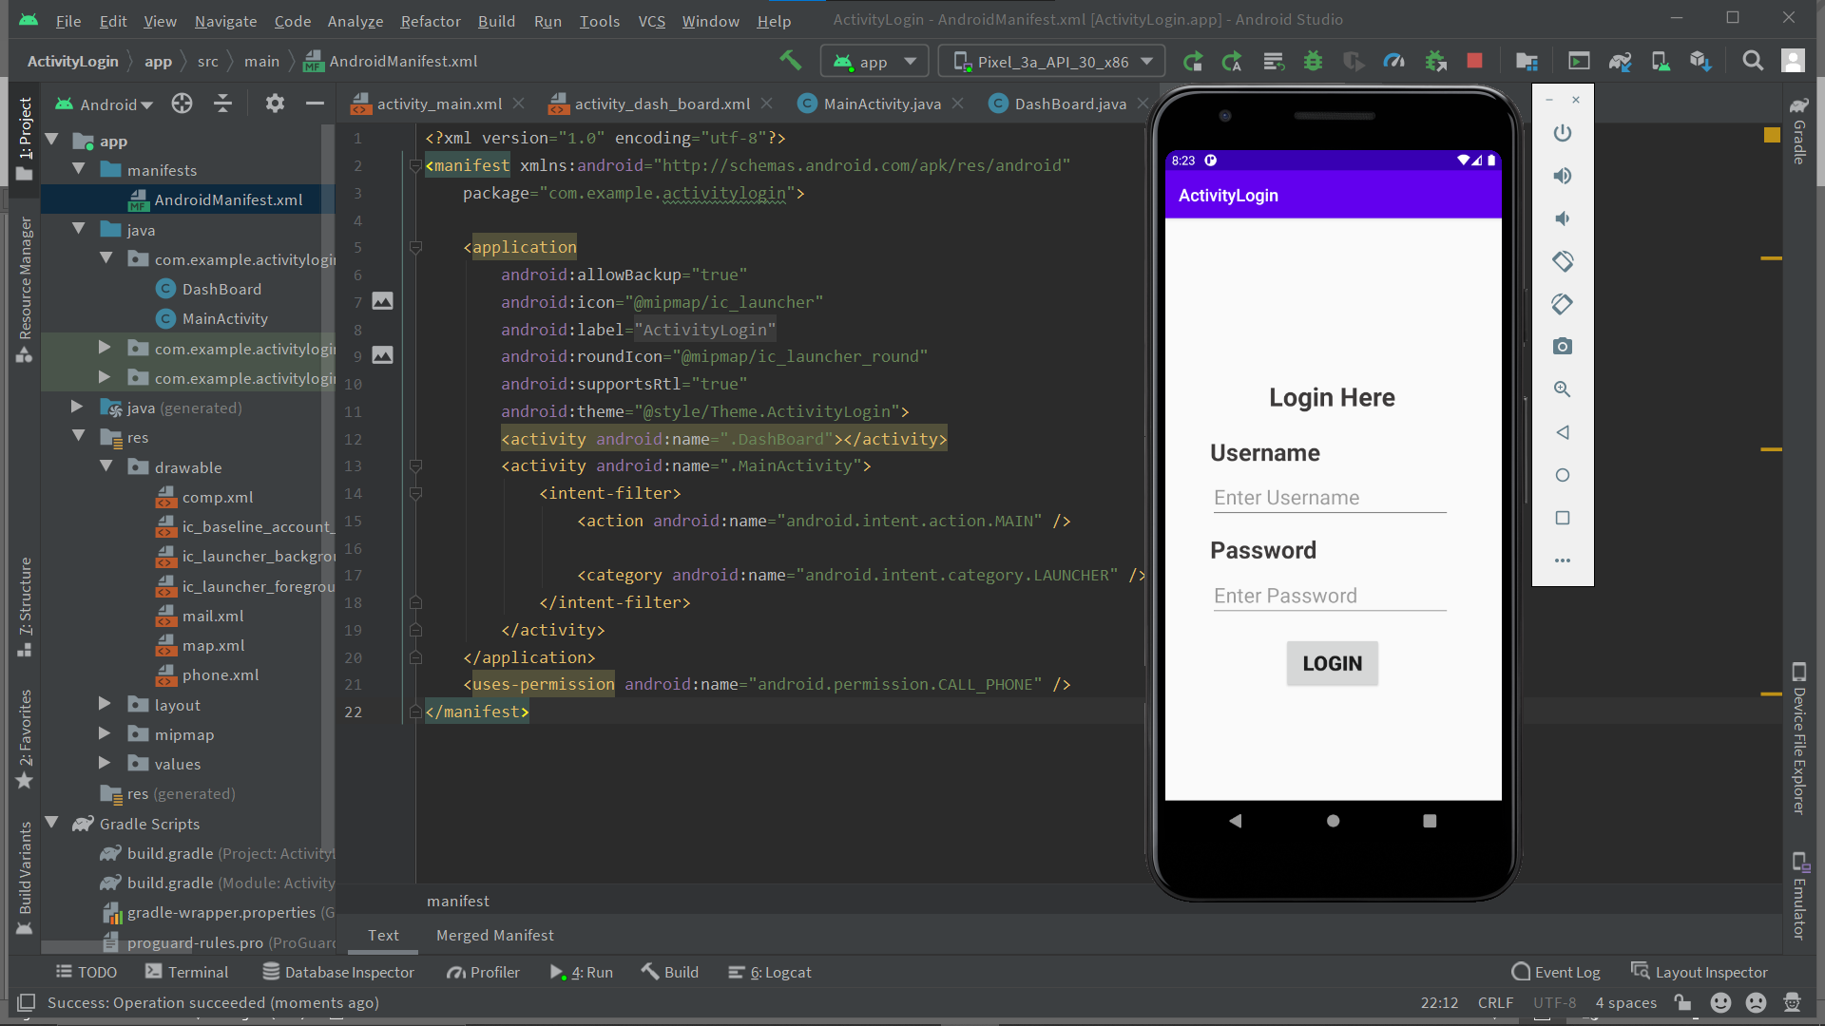

1. **Putting Data and clicking Login**

**Wrong Uname or pw -> Unsuccessful Login.**

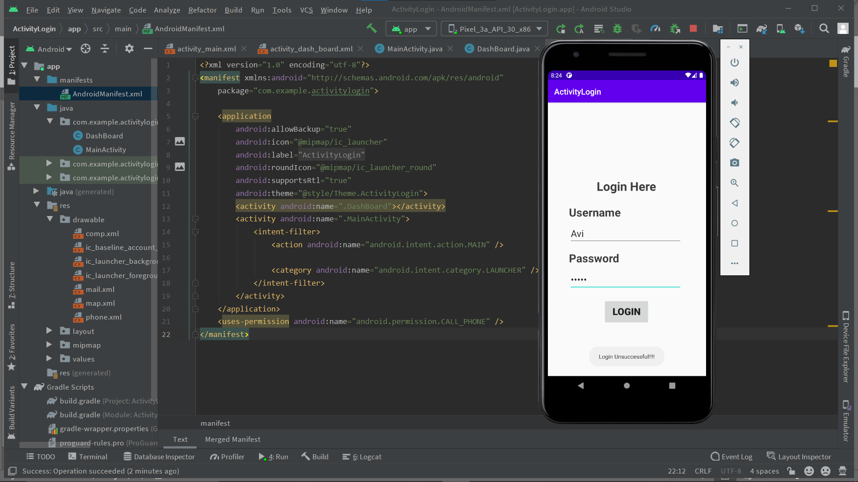

**Correct Uname or pw -> Successful Login.**

